Save the Date

Saturday, April 29, 2017
11:00 a.m. – Noon

Alabama Letters About Literature
2016-2017 Awards Ceremony

Amelia Gayle Gorgas Library

The University of Alabama
711 Capstone Drive
Tuscaloosa, Alabama

Reception to Follow

Attire: Dressy Casual ▪ Photographs will be Taken
Parking: Behind Gorgas Library on Capstone Drive
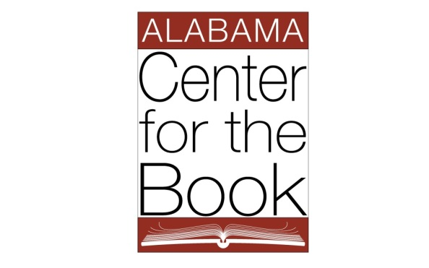
For additional information contact: Donna Adcock, 205-348-1416, dbadcock@ua.edu
